Teamwork

Slack:

Our team used Slack extensively to set meeting agenda, create to-do lists, and communicate requirements and specs, and work through challenges we faced during the development of the project.

Example snippets from our meeting agendas:

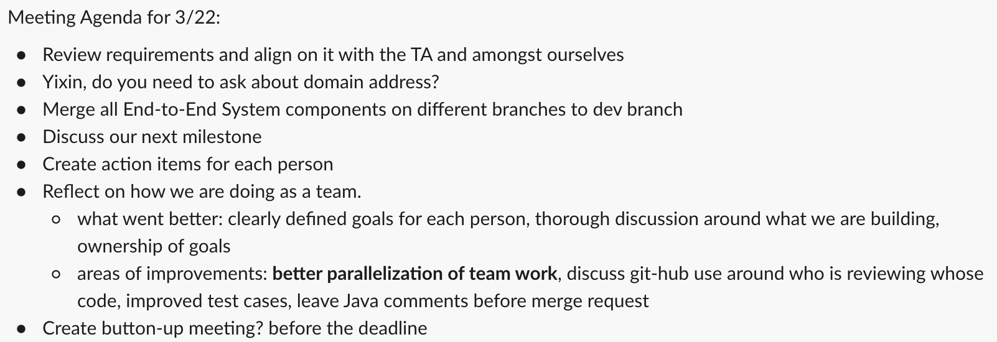

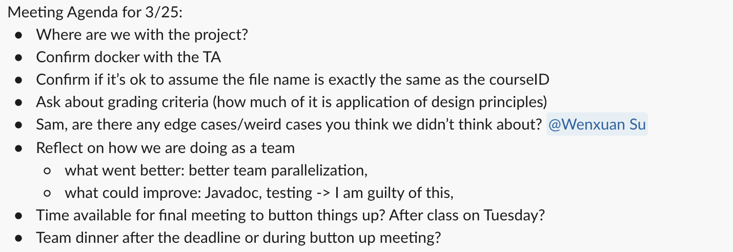

Example snippets from our task distributions:

Gitlab:

Our team also made use of Gitlab extensively. We specifically we used WIKI, CI/CD, merge requests, and issues where needed.

